SPRING INTERNSHIP PROJECT REPORT

Benchmarking Foundation Models for
Capsule Endoscopy Lesion Detection
and Segmentation using Vision-Language Models

Ishan Jha (B.Tech in Computer Science, K.R Mangalam University)

Project Guide / Mentor Name: Dr. Sujoy K Biswas

Period of Internship: 21ST January 2026 – 31st March 2026

Report submitted to: IDEAS – Institute of Data Engineering, Analytics and Science Foundation, ISI Kolkata

- Abstract
This report presents a benchmark evaluation of pretrained foundation models for automated lesion detection and segmentation in capsule endoscopy videos. The study uses the Kvasir-Capsule dataset, focusing on four clinically significant lesion classes: Ulcer, Erosion, Blood-fresh, and Polyp.
A complete data preparation pipeline was implemented, involving video splitting, bounding box annotation overlay using OpenCV, and ground truth generation from metadata annotations. Off-the-shelf vision models including CLIP and BLIP-2 were evaluated, demonstrating severe domain shift when applied to capsule endoscopy imagery.
MedSAM, a medical image segmentation foundation model, was subsequently benchmarked using batch inference with ground truth bounding boxes as prompts. Evaluation metrics including Precision, Recall, F1-score, IoU, and Dice coefficient were computed per class and compared against published Kvasir-Capsule paper benchmarks.
Results show that pretrained MedSAM achieves a Mean IoU of 0.5101 and Mean Dice of 0.6152, with high precision but very low recall, indicating that the model segments correctly when prompted but fails to generalise across the full annotation set. These findings highlight the domain gap between general medical imaging and capsule endoscopy, justifying the need for domain-specific fine-tuning.

Key Metrics at a Glance
Metric | Value | Interpretation
Mean IoU | 0.5101 | Moderate spatial overlap when predictions are made
Mean Dice | 0.6152 | Reasonable mask quality in prompted segments
Micro Precision | 0.8857 | High accuracy when the model predicts
Micro Recall | 0.0998 | Misses ~90% of all annotated findings
Annotated Frames | 1,862 | Across 4 lesion classes, 14 videos
Classes Evaluated | 4 | Ulcer, Erosion, Blood-fresh, Polyp
Table 1: Summary of key benchmark metrics for pretrained MedSAM on Kvasir-Capsule dataset

- Introduction
Capsule endoscopy is a non-invasive diagnostic procedure in which a patient swallows a small camera-equipped capsule that travels through the gastrointestinal (GI) tract, capturing thousands of images over several hours. Automated analysis of these video streams is critical for detecting clinically relevant findings such as ulcers, erosions, polyps, and bleeding. Manual review is time-consuming and prone to human error, making automated AI-assisted detection systems essential.

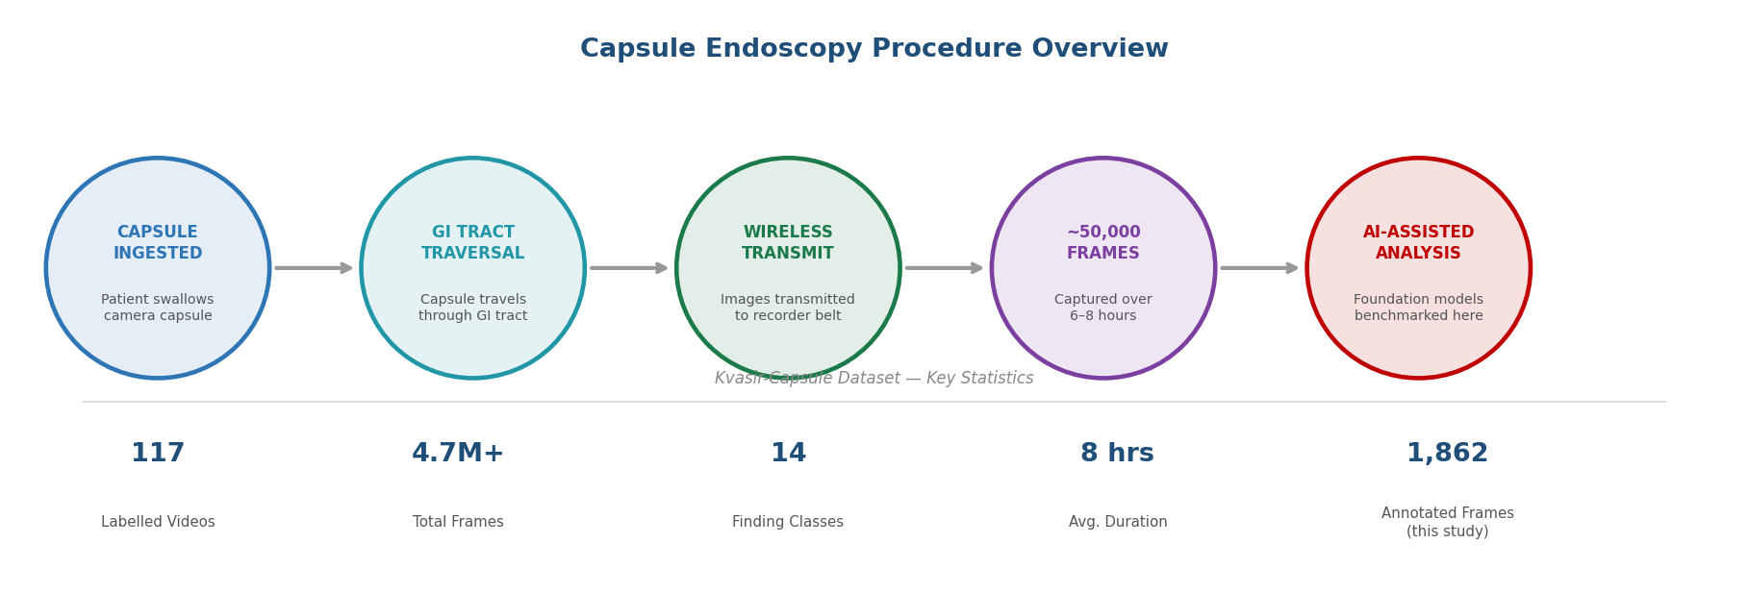
Capsule Endoscopy Procedure Diagram — showing the capsule journey through the GI tract
Figure 1: Capsule endoscopy procedure overview — stages from capsule ingestion to AI-assisted analysis, with Kvasir-Capsule dataset statistics

The Kvasir-Capsule dataset, published in Nature Scientific Data, is one of the largest publicly available capsule endoscopy datasets. It contains 117 labelled videos and over 4.7 million frames, with bounding box annotations for 14 different finding classes. This project focuses on four clinically critical classes: Ulcer, Erosion, Blood-fresh, and Polyp, covering 14 labelled videos and 1,862 annotated frames.
Foundation models such as SAM (Segment Anything Model) and its medical variant MedSAM have shown strong zero-shot segmentation capabilities across diverse medical imaging tasks. However, their performance on capsule endoscopy data — characterised by circular fisheye optics, variable lighting, and motion blur — has not been systematically evaluated. This internship project addresses this gap by constructing an evaluation pipeline and benchmarking both general vision models and MedSAM on the Kvasir-Capsule dataset.

This work makes the following contributions: (i) a complete capsule endoscopy data processing and evaluation pipeline, (ii) a systematic benchmark of general vision and segmentation foundation models, and (iii) an analysis of domain shift effects in medical imaging using zero-shot inference.
Foundation models evaluated in this study:
- CLIP (OpenAI) — Zero-shot classification using contrastive language-image pretraining
- BLIP-2 (Salesforce) — Visual Question Answering via bootstrapped vision-language model
- LLaVA 1.5 7B — Multimodal large language model for visual reasoning
- MedSAM — Medical-domain fine-tuned Segment Anything Model (primary benchmark)
- SAM (Segment Anything Model) — General-purpose segmentation baseline

Training topics covered during the first two weeks of the internship:
- Python for data science and scientific computing
- Computer vision fundamentals with OpenCV
- Video processing with MoviePy and FFmpeg
- HuggingFace Transformers pipeline API
- Foundation models: SAM, MedSAM, CLIP, BLIP-2
- Medical image analysis and evaluation metrics
- Dataset management and annotation handling

- Project Objective
The objectives of this project are elaborated below (maximum 5 objectives, in bullets):
- To build a complete data preparation pipeline for the Kvasir-Capsule video dataset, including video splitting, bounding box annotation overlay using OpenCV, and ground truth JSON generation.
- To evaluate the zero-shot performance of general-purpose vision models (CLIP, BLIP-2) on capsule endoscopy images and document their failure modes and domain shift characteristics.
- To benchmark the pretrained MedSAM model on capsule endoscopy lesion segmentation using ground truth bounding boxes as prompts across all 4 lesion classes.
- To compute and compare evaluation metrics (Precision, Recall, F1, IoU, Dice) against benchmarks reported in the Kvasir-Capsule paper.
- To demonstrate the domain gap between general medical imaging and capsule endoscopy, motivating the need for domain-specific fine-tuning approaches.

- Methodology
The project methodology consisted of six sequential stages spanning data ingestion, pipeline construction, model inference, and evaluation. All code is available on GitHub (see Appendix C).

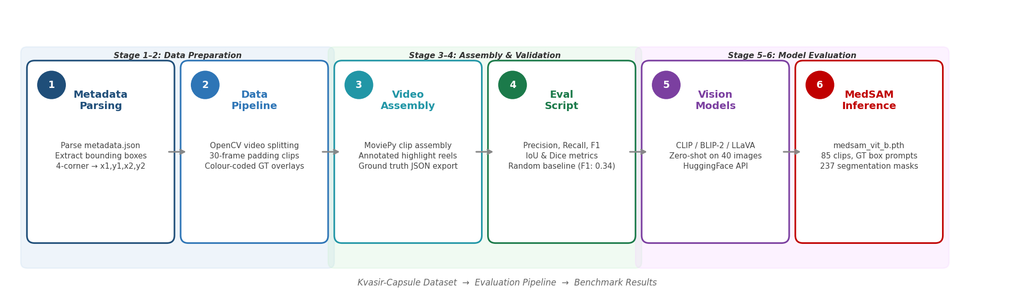
Methodology Pipeline Flowchart — 6 stages: Metadata Parsing → Data Pipeline → Video Assembly → Eval Script → Vision Models → MedSAM Inference
Figure 2: Six-stage methodology pipeline — Data Preparation (Stages 1–2), Assembly & Validation (Stages 3–4), Model Evaluation (Stages 5–6)

Stage 1–2: Data Preparation
The Kvasir-Capsule metadata.json was parsed to extract bounding box annotations per video and finding, converting four-corner coordinates into axis-aligned (x1, y1, x2, y2) format. A data preparation pipeline was built using OpenCV to split each labelled video into short finding-based clips (with 30-frame padding), draw colour-coded ground truth bounding boxes on annotated frames, and organise the 85 generated clips into class folders: Ulcer (29), Erosion (46), Blood-fresh (9), Polyp (1). Ground truth was exported as a structured ground_truth.json file.
Stage 3–4: Assembly & Validation
MoviePy’s ImageSequenceClip and concatenate_videoclips were used to assemble annotated clip videos and a combined highlight reel per original video. An evaluation script was developed computing Precision, Recall, F1, IoU, and Dice metrics per class with micro and macro averaging. A random baseline predictor validated the pipeline correctness (overall F1: 0.3412, Mean IoU: 0.074).
Stage 5–6: Model Evaluation
Three off-the-shelf vision models were tested on 40 sampled images (10 per class) via the HuggingFace Transformers API: CLIP (zero-shot classification), BLIP-2 (visual question answering), and LLaVA 1.5 7B (tested on Google Colab due to hardware constraints — 15.7 GB RAM, no local GPU). MedSAM was set up with its pretrained checkpoint (medsam_vit_b.pth), fine-tuned on over one million medical image-mask pairs across 11 imaging modalities. Batch inference was performed on all 85 clips using ground truth bounding boxes as prompts, generating 237 segmentation masks across annotated frames.
No training/testing split was performed as MedSAM was used in zero-shot inference mode with ground truth bounding boxes as prompts. Metrics were computed following the Kvasir-Capsule paper’s evaluation methodology (IoU threshold: 0.5 for TP/FP/FN classification).
All code for this project is available on GitHub: https://github.com/XylaN-xD/capsule-fm-benchmark

- Data Analysis and Results
5.1 Dataset Overview
The Kvasir-Capsule dataset statistics are tabulated below. 14 labelled videos across 4 lesion classes were used, covering 1,862 annotated frames across 85 generated clips.
Metric | Value
Total Labelled Videos (full dataset) | 117
Total Frames in Dataset | 4.7M+
Finding Classes (full dataset) | 14
Clips Generated (4 classes) | 85
Annotated Frames Used | 1,862
Classes Studied | Ulcer, Erosion, Blood-fresh, Polyp
Table 2: Kvasir-Capsule dataset statistics

5.2 Sample Lesion Frames
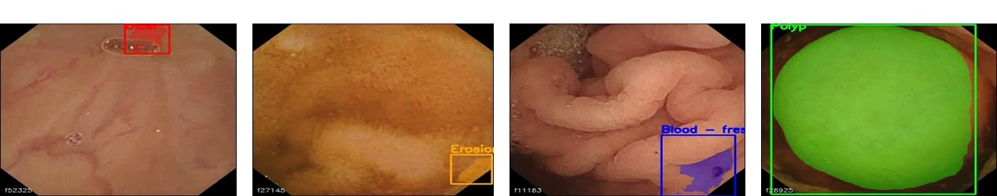
Sample annotated frames for all 4 lesion classes: Ulcer, Erosion, Blood-fresh, Polyp
Figure 3: Sample Kvasir-Capsule annotated frames with ground truth bounding boxes — Ulcer (red), Erosion (orange), Blood-fresh (blue), Polyp (green)
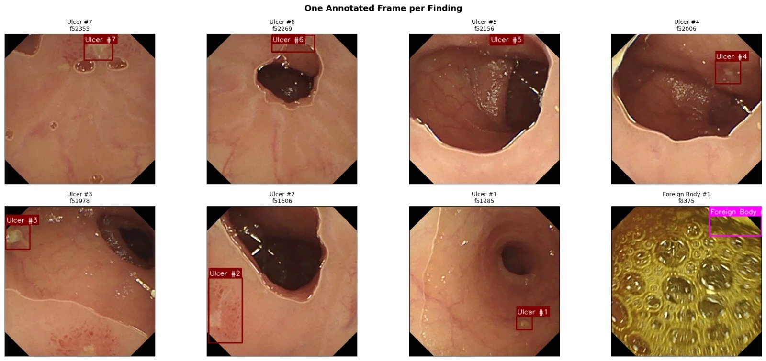
Figure 3b: One annotated frame per finding across all Ulcer clips — showing the diversity of lesion appearance, scale, and GI tract context within a single class
5.3 Off-the-Shelf Vision Model Results
All three general-purpose models were evaluated on 40 sampled images using zero-shot prompting. CLIP (OpenAI/clip-vit-base-patch32) achieved an overall accuracy of 30% (Ulcer: 40%, Erosion: 70%, Blood-fresh: 0%, Polyp: 10%), with strong majority-class bias predicting ‘Erosion’ for nearly all inputs. BLIP-2 (Salesforce/blip-vqa-base) produced hallucinated answers entirely unrelated to medical findings, mapping GI frames to everyday objects. LLaVA 1.5 7B demonstrated better semantic understanding but could not be fully benchmarked locally due to hardware constraints.
Model | Method | Overall Accuracy | Key Failure Mode
CLIP (OpenAI) | Zero-shot text prompts | 30% | Majority-class bias — predicted ‘Erosion’ for ~all inputs
BLIP-2 (Salesforce) | Visual QA | ~0% | Hallucinated answers; mapped GI frames to everyday objects
LLaVA 1.5 7B | Multimodal VQA (Colab) | Partial | Hardware limited; better semantics, classification errors
Table 3: Off-the-shelf vision model evaluation results

5.4 MedSAM Benchmark Results (IoU Threshold = 0.5)
Per-class segmentation metrics from medsam_complete_metrics.json are tabulated below. MedSAM was run in zero-shot inference mode using ground truth bounding boxes as prompts, generating 237 segmentation masks.
Class | Precision | Recall | F1 Score | TP | FP | FN
Ulcer | 0.8889 | 0.0843 | 0.1540 | 72 | 9 | 782
Erosion | 0.8800 | 0.2170 | 0.3481 | 110 | 15 | 397
Blood-fresh | 0.0000 | 0.0000 | 0.0000 | 0 | 0 | 446
Polyp | 1.0000 | 0.0714 | 0.1333 | 4 | 0 | 52
Macro Average | 0.6922 | 0.0932 | 0.1589 | — | — | —
Micro Average | 0.8857 | 0.0998 | 0.1795 | — | — | —
Table 4: MedSAM per-class metrics on Kvasir-Capsule (IoU threshold = 0.5)

Segmentation quality: Mean IoU = 0.5101, Mean Dice = 0.6152. High micro precision (0.8857) indicates accurate masks when MedSAM predicts. Micro recall of 0.0998 means the model misses ~90% of annotated findings. Blood-fresh received zero predictions, indicating it is out-of-distribution for MedSAM’s training data.

5.5 Comparison with Kvasir-Capsule Paper Benchmarks
A comparative analysis of all models is reported with the measured prediction accuracy levels below.
Model | Type | Micro F1 | Macro F1 | Notes
ResNet-152 | Fine-tuned (Paper) | 0.7340 | 0.2380 | Supervised, in-domain fine-tuning
DenseNet-161 | Fine-tuned (Paper) | 0.7350 | 0.2460 | Supervised, in-domain fine-tuning
MedSAM (ours) | Zero-shot | 0.1795 | 0.1589 | Pretrained, no capsule endo fine-tuning
Random Baseline | Baseline | 0.3412 | — | Pipeline correctness validation
Table 5: Comparison with Kvasir-Capsule paper benchmarks

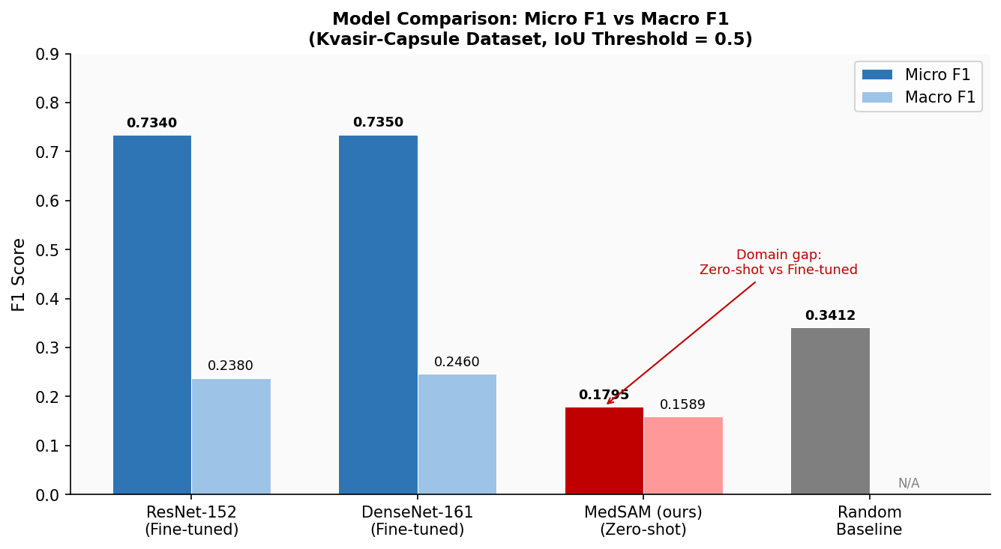
Bar chart: Micro F1 comparison — ResNet-152 vs DenseNet-161 vs MedSAM vs Random Baseline
Figure 4: Micro F1 and Macro F1 score comparison across all models — ResNet-152 vs DenseNet-161 vs MedSAM (zero-shot) vs Random Baseline (IoU threshold = 0.5)

MedSAM achieves strong spatial quality when it predicts (Mean IoU 0.5101, Mean Dice 0.6152), demonstrating effective prompting capability. However, its recall of 0.0998 confirms that zero-shot pretrained models miss the vast majority of findings and require domain-specific fine-tuning for clinical deployment.

- Conclusion
This project successfully constructed a complete data preparation and evaluation pipeline for the Kvasir-Capsule capsule endoscopy dataset. General vision models (CLIP, BLIP-2) failed entirely — CLIP achieved only 30% accuracy and BLIP-2 produced medically irrelevant hallucinations. MedSAM, despite being trained on over one million medical image-mask pairs, achieved a Micro F1 of only 0.1795 in zero-shot mode, significantly below fine-tuned ResNet-152 (0.734) and DenseNet-161 (0.735) reported in the Kvasir-Capsule paper.
MedSAM’s Mean IoU of 0.5101 and Mean Dice of 0.6152 indicate reasonable segmentation quality when it predicts, but its low recall means it misses the vast majority of findings. Blood-fresh received zero predictions, suggesting this class is particularly out-of-distribution. These results confirm that pretrained foundation models are insufficient for capsule endoscopy analysis without domain-specific adaptation.
Future work should focus on fine-tuning MedSAM on the Kvasir-Capsule dataset and exploring Video RAG pipelines with Vision LLMs for natural language querying over capsule endoscopy archives. Evaluation should be extended to all 14 Kvasir-Capsule finding classes.

- APPENDICES
You may create separate Appendix for the following:
- References (Papers, Journals, Websites etc. needed to be referred for your project)
Smedsrud, P.H., et al. (2021). Kvasir-Capsule, a video capsule endoscopy dataset. Scientific Data, 8, 142.
Ma, J., et al. (2024). Segment Anything in Medical Images. Nature Communications, 15, 654.
Kirillov, A., et al. (2023). Segment Anything. ICCV 2023.
Radford, A., et al. (2021). Learning Transferable Visual Models From Natural Language Supervision. ICML 2021.
Li, J., et al. (2022). BLIP: Bootstrapping Language-Image Pre-training. ICML 2022.
- Survey Questionnaire (if any)
Not applicable — this project does not involve a survey questionnaire.
- Github link for the codes developed (if any)
GitHub Repository: https://github.com/XylaN-xD/capsule-fm-benchmark
- Any other Document Link (A copy of this report, data sheet, presentation, etc. should be kept in github / google drive)
A copy of this report, dataset files, and presentation slides are maintained in the project repositories. GitHub: github.com/XylaN-xD/capsule-fm-benchmark/ | Google Drive: drive.google.com/drive/folders/1XQCivGj5UsD78iUjcUe_vsKN8wfFq5zy

Appendix C: Tools and Libraries Used
Tool / Library | Version | Purpose
Python | 3.12 | Primary programming language
OpenCV | 4.x | Video processing and bounding box drawing
MoviePy | 2.0 | Annotated video creation and highlight reels
HuggingFace Transformers | 5.x | CLIP, BLIP-2, LLaVA model API
MedSAM / segment_anything | Latest | Medical image segmentation
PyTorch | 2.x | Deep learning inference backend
NumPy | Latest | Numerical processing
Matplotlib | Latest | Visualisation and metric plotting
Table C1: Complete list of tools and libraries used

